RFC: Title
Author1
Author2
First, have an abstract. Briefly describe the reason for the RFC and the recommendation it makes. Provide just enough information to let the reader decide if they should keep reading, or if RFC is of no interest to them.

Introduction
Every RFC should have an introduction. Tell the reader about the problem this RFC is designed to address, or the enhancement it will provide. The introduction should give the reader enough background that they can decide if they want to keep reading.

Approach / Motivation / Etc.
Typically the first section after the Introduction will go into motivation in more depth, talk about approach or whatever you want. There is no requirement for the actual Section name. It may have subsections. Do what makes sense for your RFC.

Standard Parts of the Template
In this section, the standard parts of the template are discussed.

Headers
There is a standard header format for the RFC. It is slightly different for the first page and subsequent pages. The first page doesn’t have a blue line below the content; the subsequent pages do. You must adjust the header content on the first page and adjust it on one of the subsequent pages. The content is not “tied together”. It may be at some point, but for now, I don’t know how to do that.
Styles for headers are discussed below, but if you use the template you should not have to change them.

Header for First Page
Use the style THG Header for the first page header. You should not have to change this because it is in the template.

Date on Left Side
The date on the left side of the header should be the date this version of the RFC is published.

RFC “identifier” on Right Side
The RFC identifier should be unique for each RFC. It should always contain the RFC THG characters to start. Then yyyy-mm-dd corresponding to the Year, Month, and Day the first version of the RFC was written. Early versions may be internal to The HDF Group–that’s fine.
Following the yyyy-mm-dd is “.vX” corresponding to the version number. Start with version 1. Increment the version number each time updates are made. The yyyy-mm-dd will never change.

Header for Subsequent Pages
Use the style THG Header2 for the headers on subsequent pages. The contents are the same as for the header on the first page, but you must manually update the contents on one of the subsequent pages to keep them in sync. It is not automatic at this point.

Title
Always preface the title with “RFC:” as shown in the sample title of this template. Use the style Title (should be automatic with template)

Author(s)
List the author(s) below the title – one author per line. Use the style Author, which also adds a blue horizontal line (or rule) below the last author listed.

Abstract
The Abstract follows the author list. Use the style Abstract to justify the text with preset indents on both sides. After the Abstract, use the style Divider to insert a blue horizontal line to divide the Abstract from the Introduction. This style is used to insert the appropriate line, not for styling text.

Introduction
Always have an Introduction. See text in the sample above for suggested content. Use the style Heading1 for the heading, and the Normal style for the content of the section. Normal style is justified (no ragged edges).

Other Sections and Subsections
Organize your sections and subsections in a way that makes sense for you and your readers. The first section often consists of motivation, background or overview of approach.
Headings for sections and subsections should be numbered. Use the styles Heading 1, Heading 2, and Heading 3 for section 1, subsection 1.1, and sub-subsection 1.1.1, respectively – and so on.
Use Normal style for the contents.

What about Lists?

List
List style is demonstrated here. You have to type awhile for it to wrap around and then you see what happens. The first line is at the left margin but then you get a word wrap and indent on subsequent lines. Is this the one you want? List style uses justified text (spread out to both margins)
Here’s the second paragraph with the list style.

List Number
The List Number style numbers items. It also does the word wrap and indent as you’ll see if and when I get to this point. The list number is also justified, but you can choose not to justify if you prefer.
Here’s the second List Number

List Number2
- List Number2 style indents before it starts the list. This may be easier to read. It also wordwraps and continues. I put that long word in there (wordwraps) to show you that this List Number2 style leaves ragged edges.
- This is the second List Number 2

List Paragraph2 and List Alpha3
There is also a List Paragraph2. It indents and aligns with the content of a List Number2. This may be useful for the times you have multiple paragraphs in a list. Let’s type to the end here_and_have_a_long_word to see if we get ragged edges – we do!
This is another list paragraph2. Note there’s extra space between them.
- There’s also a List Alpha3. It is ragged as well.
- Here’s another List Alpha3. You get the idea.

Code Snippets: AKA – Plain Text
You can use the plain text style to represent code. Or, use something else if you prefer. The plain text style uses the Consolas font – it’s fixed width.
#include <stdio.h>
main()
{
int i;
for (i=1; i<10; i++) {
printf( "hello %d\n", i );
}
}

Do I Need Figures or Tables?

Figures
Figures, charts, graphs or illustrations in general should be presented with introductory text that includes a reference to the figure (Figure 1). The caption appears under the figure and is aligned with the left of the figure. The figure number in the caption is followed by a period.
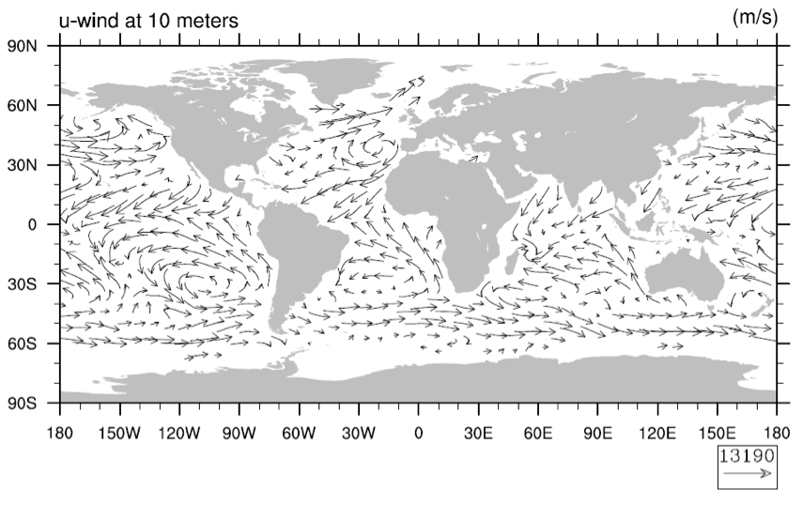
Figure 1. The caption for this figure, left-justified to left edge of figure

Tables
Tables should be preceded with introductory text that includes a reference to the table (Table 1). The caption (or title of the table) is placed above the table and includes the table number followed by a period and a brief description of the table – all in bold type (Caption Table). Table headings are based on the style Normal but have extra spacing above and below each heading (Table Heading). If your table requires a footnote(s), apply the Table Footnote style.
Table 1. Styles for an RFC document table
Heading A† | Heading B | Heading C
Body 1a | Body 1b | Body 1c
Body 2a | Body 2b | Body 2c
Body 3a | Body 3b | Body 3c
Body 4a | Body 4b | Body 4c
†Table-related footnotes go here.

What Else Do You Need?
That’s really up to you, except for the next numbered section.

Recommendation
Summarize your recommendation(s). Don’t make people read all the details to see what you are concluding and recommending. After this section there are some un-numbered sections that you should consider. At least one is required… read on.

Acknowledgements
This section is recommended but not required. Use the Heading Style for the heading of this section.
Is there anyone you want to thank and/or recognize? Was this work funded by a contract that should be cited? If so, see next paragraph for possible text on how to acknowledge them… tailor for specific document.
This work was [partially] supported by [grant, contract, cooperative agreement] number [agreement number] [from, with] [organization name (acronym)]. Any opinions, findings, conclusions, or recommendations expressed in this material are those of the author[s] and do not necessarily reflect the views of [organization].
In some cases we can’t name the customer who funded the work. In those cases, consider something like the next paragraph:
This work was supported by a customer of The HDF Group.
Or, if it was internally funded:
This work was internally funded by The HDF Group.

Revision History
This section is required and it should be updated with each version change. Use the Heading style for the heading of the section.
A table with no bounding lines is used to format the content. To add a new row to the table position your cursor to the right of an existing row and hit <return>. A new row will be added below the existing table row.
The first column contains the date when the version was published. The second column should note the version number and say what it did / what changed.
If this is the first version that was published for public comment, tell the reader where to send comments, as in the Version 3 example in the table below.
June 7, 2008: | Version 1 circulated for comment within The HDF Group.
July 2, 2008: | Version 2 incorporates feedback, especially to section 3; circulated for internal comment.
August 2, 2008: | Version 3 posted for public comment. Comments should be sent to author@hdfgroup.orgor help@hdfgroup.org.
September 7, 2008: | Version 4 incorporates feedback from the public, especially in section 4.x. Comment period ended. Implementation will be based on this Version.
December 12, 2008: | Version 5 contains small revisions that came up during implementation. Functionality available with HDF5 release 1.10.0. See design document XXXX, HDF5 Reference Guide topic YYYYY, and HDF5 Reference Manual Entries H5Gxxx() and H5Tyyy for further information.
August 26, 2009: | This is for the RFC template and not just an example. The template was updated slightly to try and address some compatibility issues with the header when the document is saved to the older Word format. In addition, the revision history section was redone with a table. A few other minor updates were also made.

Appendix: Background Material
This appendix contains background material, including assumptions and high-level design decisions that guided the final approach presented in the body of the RFC.
This information is not required but is often a good idea especially as you work through the various versions of the RFC, or even before you begin to write. If you note the reasons you opted for one approach over another, or perhaps include content from an earlier version that was changed based on feedback, it is good to maintain a record. Memories are not perfect, and sometime thought processes that are documented help readers (and developers) understand better how you decided to take the approach you chose.

Glossary, Terminology
This section is not required, but is highly recommended if there are terms in the RFC that may not be familiar to the readers.
aterm | Alphabetize the words that appear in the document and that you want to provide definitions for.
dterm | You may not have a glossary (or terminology) section.

References
You may not have references, but if you do put them here. In general, it is good to include references to sources you used.
- The HDF Group. “HDF5 Documentation,” http://www.hdfgroup.org/HDF5/doc/doc-info.html (June 14, 2010).
- Karyampudi, V., and T. Carlson. 1988. Analysis and numerical simulations of the Saharan air layer and its effect on easterly wave disturbances. J. Atmos. Sci. 45: 3102-3136.
- Martin, C. and Y. Zhang. 2005. The diverse functions of histone lysine methylation. Nature Rev. Mol. Cell Biol. 6, 838–849.
- Shu, S., and L. Wu. 2009. Analysis of the influence of Saharan air layer on tropical cyclone intensity using AIRS/AQUA data, Geophys. Res. Lett., 36, L09809.

All authors should be included in reference lists unless there are more than five, in which case only the first author should be given, followed by 'et al.'.
Please follow the style below in the published edition of Nature in preparing reference lists.
* Authors should be listed by surname first, followed by a comma and initials of given names.
* Titles of all cited articles are required. Titles of articles cited in reference lists should be in upright, not italic text; the first word of the title is capitalized, the title written exactly as it appears in the work cited, ending with a full stop. Book titles are italic with all main words capitalized. Journal titles are italic and abbreviated according to common usage; authors can refer to Nature, the Index Medicus or the American Institute of Physics style manual for details.
* Volume numbers are bold. The publisher and city of publication are required for books cited. (Refer to published papers in Nature for details.)
* References to web-only journals should give authors, article title and journal name as above, followed by the URL in full – or the DOI if known – and the year of publication in parentheses.
* References to websites should provide author names if known (or the company name), the title of cited page, the full URL, and the year of posting, or date of page updated, in parentheses, if known.

